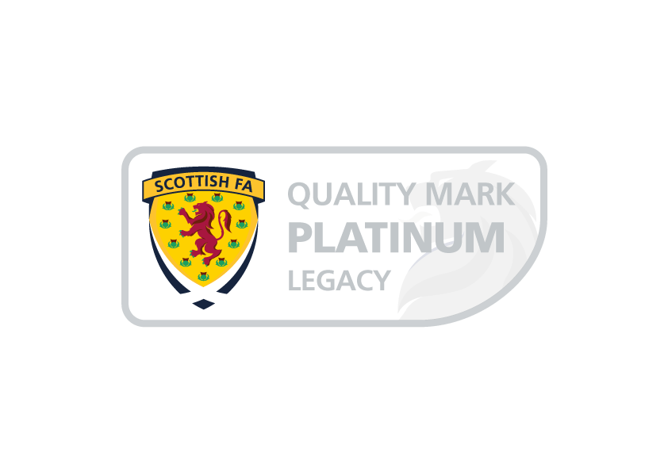
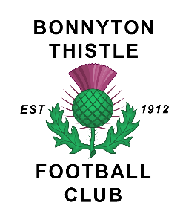

Bonnyton Thistle Football Club Unacceptable Conduct Policy
Unacceptable Conduct means.
(i) Conduct which incites or sustains, or is likely or designed to incite or sustain, hatred or ill will against or towards a group or persons based on their membership or presumed membership of a group defined by reference to a Category or against an individual who is or is presumed to be of the following categories:
- Gender, colour, race, nationality (including citizenship) or ethnic or national origin
- Membership or presumed membership, of a religious group or of a social or cultural group with perceived religious affiliation
- Sexual orientation
- Transgender identity
- Disability

by the person or persons engaged in the Conduct to be a member of such group.
(ii) Using threatening, abusive or insulting words or conduct
(iii) Displaying any writing or other thing which is threatening, abusive or insulting, or
(iv) Using words or conduct or displaying wiring or other thing which indicates support for, or affiliation to, or celebration of, or opposition to an organisation or group proscribed in terms of the Terrorism Act 2000, and any successive or replacement legislation thereto:
Sanctions.
Any Person committing Disorderly conduct and/or any person who assists another or others to commit Disorderly conduct, may be subject to any, or a combination of the following;
- Refusal of entry to the stadium
- Removal from the stadium
- Suspension from attending matches of Bonnyton Thistle FC
- Indefinite ban from attending matches of Bonnyton Thistle FC
- Be the subject of a report to Police Scotland and/or any prosecuting authorities which may result in possible criminal proceedings.

Reviewed 22nd October 2021
Next review 21st October 2022

