CONSTITUTION

of

Bonnyton Thistle Football Club

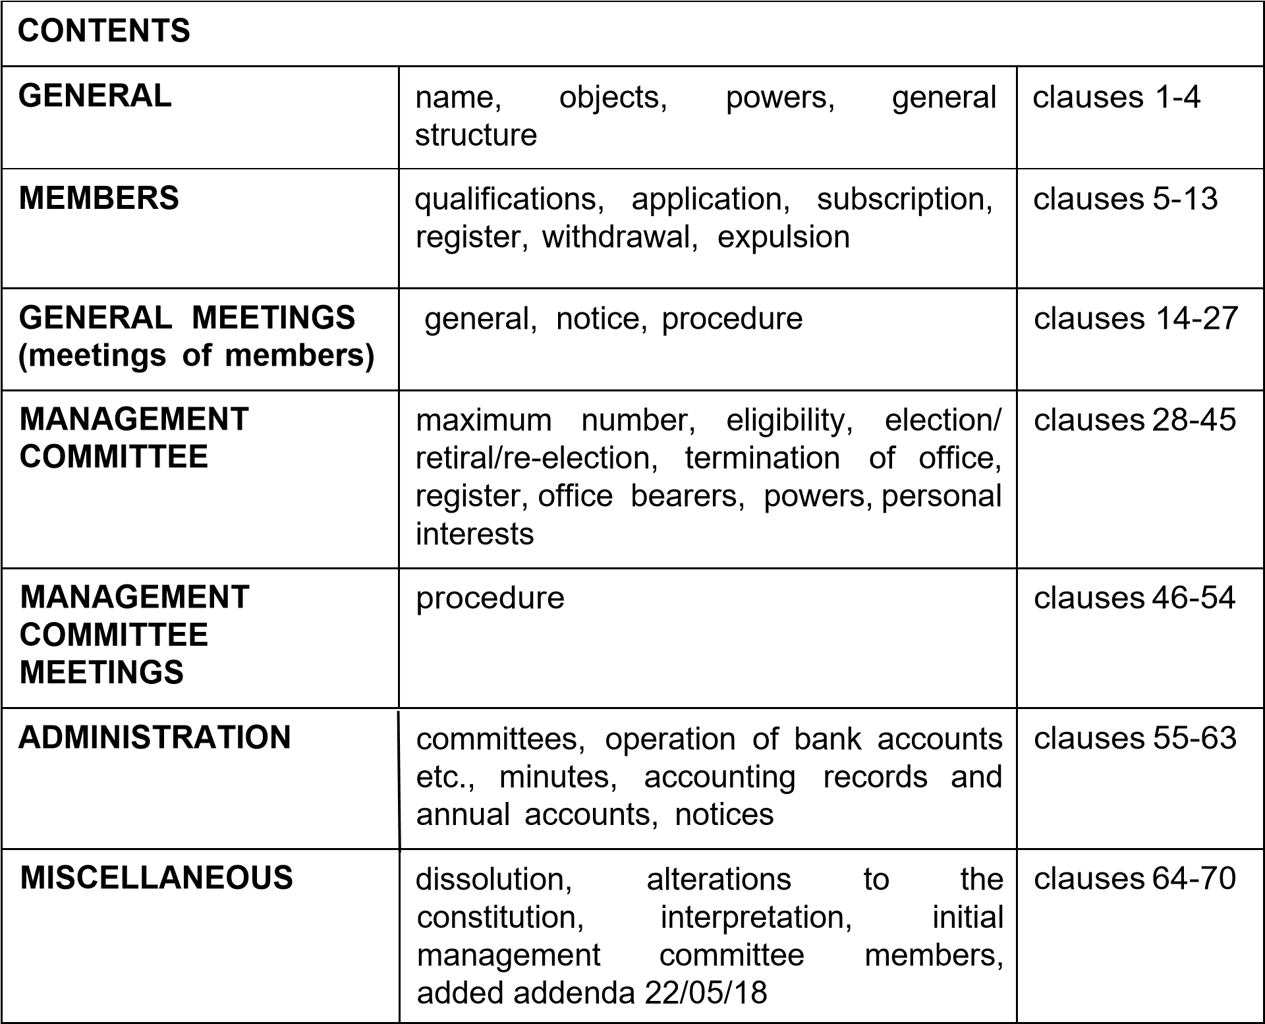

Name

1 The name of the association is "Bonnyton Thistle Football Club".

Objects
2. The association's objects are:

The advancement of public participation in sport.

Powers

3. In pursuance of the objects set out in clause 2 (but not otherwise), the association shall have the following powers:-

- To foster, promote & develop the participation by children,
youths & adults of all abilities in organised football

- To carry on any other activities which further any of the above objects.

- To purchase, take on lease, hire, or otherwise acquire, any property or rights which are suitable for the association's activities.

- To improve, manage, develop, or otherwise deal with, all or any part of the property and rights of the association.

- To sell, let, hire out, license, or otherwise dispose of, all or any part of the property and rights of the association.

- To borrow money, and to give security in support of any such borrowings by the association.

- To employ such staff as are considered appropriate for the proper conduct of the association's activities, and to make reasonable provision for the payment of pension and/or other benefits for members of staff, ex-members of staff and their dependents.

- To engage such consultants and advisers as are considered appropriate from time to time.

- To effect insurance of all kinds (which may include officers' liability insurance).

U) To invest any funds which are not immediately required for the association's activities in such investments as may be considered appropriate (and to dispose of, and vary, such investments).

(k) To liaise with other voluntary sector bodies, local authorities, UK or Scottish government departments and agencies, and other bodies, all with a view to furthering the association's objects.
(I) To establish and/or support any other charity, and to make donations for any charitable purpose falling within the association's objects.

- To form any company which is a charity with similar objects to those of the association, and, if considered appropriate, to transfer to any such company (without any payment being required from the company) the whole or any part of the association's assets and undertaking.

- To take such steps as may be deemed appropriate for the purpose of raising funds for the association's activities.

- To accept grants, donations and legacies of all kinds (and to accept any reasonable conditions attaching to them).

- To do anything which may be incidental or conducive to the furtherance of any of the association's objects.

General structure

4. The structure of the association shall consist of:-

- the MEMBERS- who have the right to attend the annual general meeting (and any special general meeting) and have important powers under the constitution; in particular, the members elect people to serve on the management committee and take decisions in relation to changes to the constitution itself

- the MANAGEMENT COMMITTEE - who hold regular meetings during the period between annual general meetings, and generally control and supervise the activities of the association; in particular, the management committee is responsible for monitoring the financial position of the association.

Qualifications for membership

- Membership shall be open to all.

- An employee of the association shall not be eligible for membership; a person who becomes an employee of the association after admission to membership shall automatically cease to be a member.

Application for membership

- Any person who wishes to become a member must sign, and lodge with the association, a written application for membership.

- The management committee may, at its discretion, refuse to admit any person to membership.

- The management committee shall consider each application for membership at the first management committee meeting which is held after receipt of the application; the management committee shall, within a reasonable time after the meeting, notify the applicant of its decision on the application.

Membership subscription

10. Membership subscription shall be based on a 12 month subscription or donation to Bonnyton Thistle FC charitable trust. All monies received will remain the property of Bonnyton Thistle FC charitable trust. Team or age group disbanded who are in control of accrued and assumed funds, will revert team or age group funds to the main bank account of Bonnyton Thistle FC charitable trust i.e. club accounts.

Register of members

11. The trustee committee shall maintain a register of members, setting out the full name and address of each member, the date on which s/he was admitted to membership, and the date on which any person ceased to be a member.

Withdrawal from membership

12. Any person who wishes to withdraw from membership shall sign, and lodge with the association, a written notice to that effect; on receipt of the notice by the association, s/he shall cease to be a member.

Expulsion from membership

13. Any person may be expelled from membership by way of a resolution passed by majority vote at a general meeting (meeting of members), providing the following procedures have been observed:-

- at least 21 days' notice of the intention to propose the resolution must be given to the member concerned, specifying the grounds for the proposed expulsion

- the member concerned shall be entitled to be heard on the resolution at the general meeting at which the resolution is proposed.

General meetings (meetings of members)

- The management trustees shall convene an annual general meeting in each year (but excluding the year in which the association is formed); not more than 15 months shall elapse between one annual general meeting and the next.

- The business of each annual general meeting shall include:-

  - a report by the trustees on the activities of the association

  - consideration of the annual accounts of the association

  - the e l e c t i o n /re-election of members of the trustee committee, as referred to in clause 30.

- The trustee committee may convene a special general meeting at any time.

Notice of general meetings

- At least 14 clear days' notice must be given (in accordance with clause 63) of any annual general meeting or special general meeting; the notice must indicate the general nature of any business to be dealt with at the meeting and, in the case of a resolution to alter the constitution, must set out the terms of the proposed alteration.

- The reference to "clear days" in clause 17 shall be taken to mean that, in calculating the period of notice, the day after the notice is posted, and also the day of the meeting, should be excluded.
Bonnyton Thistle FC is a registered Scottish charity SC044922
Warwickhill Road, Kilmarnock, KA1 2LT

- Notice of every general meeting shall be given (in accordance with clause 63) to all the members of the association, and to all the members of the trustee committee.

Procedure at general meetings

- No business shall be dealt with at any general meeting unless a quorum is present; the quorum for a general meeting shall be 10 members, present in person.

- If a quorum is not present within 30 minutes after the time at which a general meeting was due to commence - or if, during a meeting, a quorum ceases to be present - the meeting shall stand adjourned to such time and place as may be fixed by the chairperson of the meeting.

- Any trustee of the association shall (if present and willing to act as chairperson) preside as chairperson of each general meeting; if the chair is not present and willing to act as chairperson within 30 minutes after the time at which the meeting was due to commence, the members of the management committee present at the meeting shall elect from among themselves the person who will act as chairperson of that meeting.

- The chairperson of a general meeting may, with the consent of the meeting, adjourn the meeting to such time and place as the chairperson may determine.

- Every member shall have one vote, which (whether on a show of hands or on a secret ballot) must be given personally.

- A resolution put to the vote at a general meeting shall be decided on a show of hands unless a secret ballot is demanded by the chairperson (or by at least two members present in person at the meeting); a secret ballot may be demanded either before the show of hands takes place, or immediately after the result of the show of hands is declared.

- If a secret ballot is demanded, it shall be taken at the meeting and shall be conducted in such a manner as the chairperson may direct; the result of the ballot shall be declared at the meeting at which the ballot was demanded.

Maximum number of management committee members

27. The maximum number of members of the management committee (who will be "Trustees") shall be 9.

Eligibility

28. A person shall not be eligible for election/appointment to the trustee committee unless he/she is a member of the association.

Election, retiral, re-election

- At each annual general meeting, the members may (subject to clause 28) elect any member to be a member of the trustee committee.
- The trustee committee may at any time appoint any member to be a member of the trustee committee (subject to clause 28).

- At each annual general meeting, all of the members of the trustee committee shall retire from office - but shall then be eligible for reelection.

Termination of office

32. A member of the trustee committee shall automatically vacate office if:-

- he/she becomes debarred under any statutory provision from being a charity trustee

- he/she becomes incapable for medical reasons of fulfilling the duties of his/her office and such incapacity is expected to continue for a period of more than six months

- he/she ceases to be a member of the association

- he/she becomes an employee of the association

- he/she resigns office by notice to the association

- he/she is absent (without permission of the trustee committee) from more than four consecutive meetings of the trustee committee, and the trustee committee resolve to remove him/her from office.

Register of trustee committee members

33. The trustee committee shall maintain a register of trustee committee members, setting out the full name and address of each member of the management committee, the date on which each such person became a trustee committee member, and the date on which any person ceased to hold office as a trustee committee member.

Office bearers

- The trustee committee members shall elect from among themselves a treasurer and a secretary, and such other office bearers (if any) as they consider appropriate.

- All of the office bearers shall cease to hold office at the conclusion of each annual general meeting, but shall then be eligible for re-election.

- A person elected to any office shall cease to hold that office if he/she ceases to be a member of the trustee committee or if he/she resigns from that office by written notice to that effect.

Powers of trustee committee

- Except as otherwise provided in this constitution, the association and its assets and undertaking shall be managed by the trustee committee, who may exercise all the powers of the association.

- A meeting of the trustee committee at which a quorum is present may exercise all powers exercisable by the trustee committee.
Bonnyton Thistle FC is a registered Scottish charity SC044922
Warwickhill Road, Kilmarnock, KA1 2LT

Personal interests

- A member of the trustee committee who has a personal interest in any transaction or other arrangement which the association is proposing to enter into, must declare that interest at a meeting of the trustee committee; he/she will be debarred (in terms of clause
52) from voting on the question of whether or not the association should enter into that arrangement.

- For the purposes of clause 40, a person shall be deemed to have a personal interest in an arrangement if any partner or other close relative of his/hers or any firm of which he/she is a partner or any limited company of which he/she is a substantial shareholder or director, has a personal interest in that arrangement.

- Provided

  - he/she has declared his/her interest

  - he/she has not voted on the question of whether or not the association should enter into the relevant arrangement and

  - the requirements of clause 44 are complied with,

a member of the trustee committee will not be debarred from entering into an arrangement with the association in which he/she has a personal interest (or is deemed to have a personal interest under clause 41) and may retain any personal benefit which he/she gains from his/her participation in that arrangement.

- No member of the trustee committee may serve as an employee (full time or part time) of the association, and no member of the trustee committee may be given any remuneration by the association for carrying out his/her duties as a member of the trustee committee.

- Where a trustee committee member provides services to the association or might benefit from any remuneration paid to a connected party for such services, then

  - the maximum amount of the remuneration must be specified in a written agreement and must be reasonable

  - the trustee committee members must be satisfied that it would be in the interests of the association to enter into the arrangement (taking account of that maximum amount)

  - less than half of the trustee committee members must be receiving remuneration from the association (or benefit from remuneration of that nature).

- The members of the trustee committee may be paid all travelling and other expenses reasonably incurred by them in connection with their attendance at meetings of the trustee committee, general meetings, or meetings of committees, or otherwise in connection with the carrying-out of their duties.

Procedure at trustee committee meetings

- Any member of the trustee committee may call a meeting of the trustee committee or request the secretary to call a meeting of the trustee committee.

- Questions arising at a meeting of the trustee committee shall be decided by a majority of votes.

- No business shall be dealt with at a meeting of the trustee committee unless a quorum is present; the quorum for meetings of the trustee committee shall be 5.

- If at any time the number of trustee committee members in office falls below the number fixed as the quorum, the remaining trustee committee member(s) may act only for the purpose of filling vacancies or of calling a general meeting.

- The trustee committee members present shall elect from among themselves the person who will act as chairperson of the meeting.

- The trustee committee may, at its discretion, allow any person who they reasonably consider appropriate, to attend and speak at any meeting of the management committee; for the avoidance of doubt, any such person who is invited to attend a trustee committee meeting shall not be entitled to vote.

- A trustee committee member shall not vote at a trustee committee meeting (or at a meeting of a committee) on any resolution concerning a matter in which he/she has a personal interest which conflicts (or may conflict) with the interests of the association; he/she must withdraw from the meeting while an item of that nature is being dealt with.

- For the purposes of clause 52, a person shall be deemed to have a personal interest in a particular matter if any partner or other close relative of his/hers or any firm of which he/she is a partner or any limited company of which he/she is a substantial shareholder or director, has a personal interest in that matter.

Conduct of members of the trustee committee

54. Each of the members of the trustee committee shall, in exercising his/her functions as a member of the trustee committee of the association, act in the interests of the association; and, in particular, must

- seek, in good faith, to ensure that the association acts in a manner which is in accordance with its objects (as set out in this constitution)
Bonnyton Thistle FC is a registered Scottish charity SC044922
Warwickhill Road, Kilmarnock, KA1 2LT

- act with the care and diligence which it is reasonable to expect of a person who is managing the affairs of another person

- in circumstances giving rise to the possibility of a conflict of interest of interest between the association and any other party

  - put the interests of the association before that of the other party, in taking decisions as a member of the trustee committee

  - where any other duty prevents him/her from doing so, disclose the conflicting interest to the association and refrain from participating in any discussions or decisions involving the other members of the trustee committee with regard to the matter in question

- ensure that the association complies with any direction, requirement, notice or duty imposed on it by the Charities and Trustee Investment (Scotland) Act 2005.

Delegation to sub-committees

- The trustee committee may delegate any of their powers to any subcommittee consisting of one or more trustee committee members and such other persons (if any) as the trustee committee may determine; they may also delegate to the chair of the association (or the holder of any other post) such of their powers as they may consider appropriate.

- Any delegation of powers under clause 55 may be made subject to such conditions as the trustee committee may impose and may be revoked or altered.

- The rules of procedure for any sub-committee shall be as prescribed by the trustee committee.

Operation of accounts and holding of property

- The signatures of two out of three signatories appointed by the trustee committee shall be required in relation to all operations (other than lodgment of funds) on the bank and building society accounts held by the association; at least one out of the two signatures must be the signature of a member of the trustee committee.

- The title to all property (including any land or buildings, the tenant's interest under any lease and (so far as appropriate) any investments) shall be held either in the names of the chair, treasurer and secretary of the association (and their successors in office) or in name of a nominee company holding such property in trust for the association; any person or body in whose name the association's property is held shall act in accordance with the directions issued from time to time by the trustee committee.

Minutes

60. The trustee committee shall ensure that minutes are made of all proceedings at general meetings, trustee committee meetings and meetings of committees; a minute of any meeting shall include the names of those present, and (as far as possible) shall be signed by the chairperson of the meeting.

Accounting records and annual accounts

- The trustee committee shall ensure that proper accounting records are maintained in accordance with all applicable statutory requirements.

- The trustee committee shall prepare annual accounts, complying with all relevant statutory requirements; if an audit is required under any statutory provisions or if they otherwise think fit, they shall ensure that an audit of such accounts is carried out by a qualified auditor.

Notices

63. Any notice which requires to be given to a member under this constitution shall be in writing; such a notice may either be given personally to the member or be sent by post in a pre-paid envelope addressed to the member at the address last intimated by him/her to the association.

Dissolution

Alterations to the constitution

- Subject to clause 68, the constitution may be altered by a resolution passed by not less than two-thirds of those present and voting at a general meeting, providing due notice of the meeting, and of the resolution, is given in accordance with clauses 17, 18 and 19

- No amendment to clauses 3, 43, 65 or 66 of the constitution may be made if the effect would be that the association would cease to be a charity

Interpretation

- For the purposes of this constitution,

  - the expression "charity" shall mean a body which is either a "Scottish charity" within the meaning of section 13 of the Charities and Trustee Investment (Scotland) Act 2005 or a "charity" within the meaning of section 96 of the Charities Act 1993

  - the expression "charitable purpose" shall mean a charitable purpose under section 7 of the Charities and Trustee Investment (Scotland) Act 2005 which is also regarded as a charitable purpose in relation to the application of the Taxes Acts;

- Any reference in this constitution to a provision of any legislation shall include any statutory modification or re-enactment of that provision in force from time to time.

Initial members of the trustee committee

68. The initial members of the trustee committee, and the positions held by each, shall be as set out below.

This constitution was adopted on 16/06/2014

Signature Name Address Position
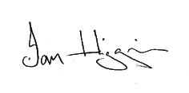
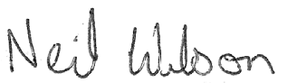
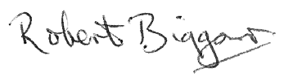
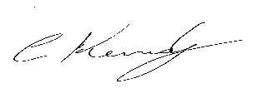
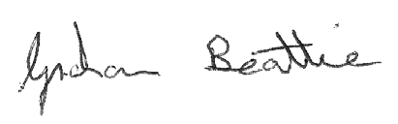
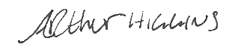
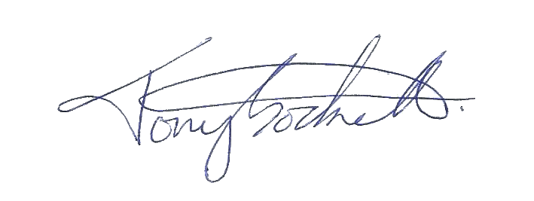
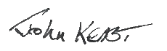
Ian Higgins 18 Forest Grove, Kilmarnock Trustee

Neil Wilson 7 Mount Avenue, Kilmarnock Trustee

John Keast 39 Lennox Crescent, Kilmarnock Trustee

Bobby Biggar 7 Salisbury Avenue, Hurlford Trustee

Colin Kennedy 17 Porting Cross Pl, Kilmarnock Trustee

Graham Beattie 12 Ferguson Gardens, Kilmarnock Trustee

Arthur Higgins 4 Holmes Village, Kilmarnock Trustee

Tony Sockell 33 Whiteside Drive, Kilmarnock Trustee

Added addenda 22/05/18

69. The addendum to the constitution, agreed and confirmed at a Trustee meeting May 22nd 2018 is as follows:-
Reference made to sub section 7, in terms of fiscal responsibilities and authorities of trustees regarding financial, overall, and particular, positions regarding same.

- No trustee, employee, or anyone involved with Bonnyton Thistle Football Club, will directly or indirectly benefit financially if the club should cease community activity, football or other sporting activities.

- In the event of the demise of any part, or all of Bonnyton Thistle Football
Club SCIO 44922
All residual financial issues will be referred to OSCAR, by way of nominated auditor or accountants. No remuneration(s) will be allowed or available to any member of the said club, on the dissolution of Bonnyton Thistle F.C.

These conditions were agreed without comment or opposition, and will be fully incorporated as part of the constitution via the pending Club AGM. Decisions were by the way of Trustee meeting 22.5.18.

Added addenda 16/01/20

This addendum to the constitution, agreed and confirmed at Trustee meeting on
16/1/20 is as follows :-
Constitute the fact changes are incorporated and included to include future planning including new members named below and deletions of memberships as stated in past minutes.
Included Members -
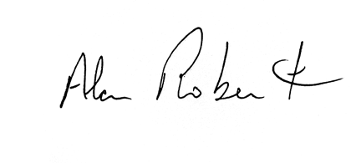
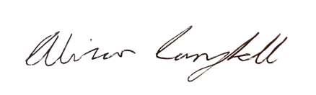
Alan Robertson 68 Larchfield Avenue, Glasgow Trustee

Alistair Campbell 24 Strathlea Crescent, Kilmarnock Trustee
Deleted Members –
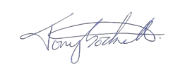
Tony Sockell 33 Whiteside Drive, Kilmarnock Trustee

Bobby Biggar 7 Salisbury Avenue, Hurlford Trustee
John Keast 39 Lennox Crescent, Kilmarnock Trustee

