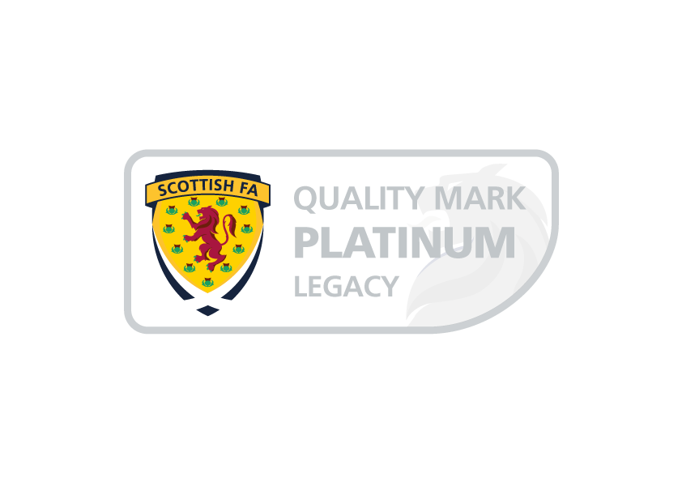

Bonnyton Thistle Football Club
Equality, Diversity and Inclusion Public Statement

Bonnyton Thistle Football Club is committed to remove and eliminate any direct or indirect discrimination of any form or kind within Bonnyton Thistle Football Club’s structures, and will under no circumstances condone unlawful discriminatory practices. The organisation takes a zero-tolerance approach to discrimination, harassment, victimisation or bullying.
Bonnyton Thistle Football Club endorses the principle of Equality and is committed to ensure that everyone who wishes to be involved with Bonnyton Thistle, regardless of their role, current or potential:
- have a genuine and equal opportunity to participate to the full extent of their own ambitions and abilities, regardless of their age, sex, gender identity, disability, marital or civil partnership status, pregnancy or maternity, religion, race, socioeconomic status or sexual orientation; and
- can be assured of an environment in which their rights and dignity and individual worth are respected and valued, and in particular that they are able to be involved and participate without the threat of discrimination, intimidation, victimisation, bullying, harassment or abuse.

